**QUESTION NO: 7(a)**

**How well you understand Multiplexer, De- multiplexer, and Encoder? Explain with suitable applications**

* **MULTIPLEXER:**
* It is a device which accepts ‘2n’ number of signals and output only one signal of desired frequency at a time.
* The lines which decides whether which input line’s signal go towards the output are called selecting input lines which are ‘n’ in number.
* For example, consider 2*1 MUX . It has 2 inputs i-e ‘21’ and 1 selecting input line and 1 output.

**2N INPUT LINES**

**MUX**

**1 OUTPUT**

**.**

**.**

**.**

**. . ….**

**N-SELECT LINES**

* **APPLICATIONS OF MULTIPLEXER:**
* **COMPUTER COMMUNICATION SYSTEMS:**

The purpose of communication systems is to receive the signals from transmitter(input) and select the desired frequency signal and move it towards the receiver(output). To get the things done, multiplexers are used.

* **COMPUTER MEMORY:**

Multiplexers are used in computer memory used to fetch desired data from memory. Our data whole data is connected to its input line and computer has just to give the selecting input to pick the desired data.

* **DE-MULTIPLEXER:**
* It is a device which accept ‘only 1’ signal as input and output ‘2n’ signals of desired frequency at a time. It has ‘n’ selecting inputs.
* For example, consider 1*8 line decoder. It has 1 input and ‘23’ i-e ‘8’ outputs. And 3 select inputs.
* It is the reverse of multiplexer.
* It receive only one signal and output the signal at the desired stations(outputs).

**1 INPUT LINE**

**DE-MUX**

**2­N OUTPUT LINES**

* **. .**
  + - **.**

**N SELECT INPUTS**

* **APPLICATIONS OF DE-MULTIPLEXER:**
* **COMPUTER COMMUNICATION SYSTEMS:**

The purpose of communication systems is to receive the signals from transmitter(input) and select the desired frequency signal and move it towards the receiver(output). To get the things done, DE-multiplexers are also used.

* **ARITHMATIC AND LOGIC UNIT:**

The purpose of demultiplexers in ALU is to receive the arithmetic and logical operations output from ALU and move it to the required stations through multiple output lines.

* **ENCODER:**
* An encoder gives the opposite output as that of a decoder.
* Encoder has ‘**2n**’ input lines and ‘**n**’ output lines which is the reverse of decoder.
* For example, consider 4*2 encoder. It has 4 inputs and 2 outputs. If the ‘I0’ of the decoder input will give signal i-e ‘on’ then the output will be its subscript code i-e ‘00’(0). And so on.

**2N INPUT LINES**

**ENCODER**

**N OUTPUT**

**.**

**.**

**.**

* **. .**

**.**

* **APPLICATIONS OF ENCODER:**
* Analog to digital converter
* robotics

**QUESTION NO: 7(b)**

Examine the logic of full adder circuit and implement with:

i. A decoder. Draw neat and clean diagram. (Attach Simulated circuit diagram as well).

* **TRUTH TABLE OF FULL ADDER:**

|  |  |  |  |  |  |
| --- | --- | --- | --- | --- | --- |
| **A(MSB)** | **B** | **CIN** | **SUM** | **COUT** | **DECODER** |
| **0** | **0** | **0** | **0** | **0** | **Y0** |
| **0** | **0** | **1** | **1** | **0** | **Y1** |
| **0** | **1** | **0** | **1** | **0** | **Y2** |
| **0** | **1** | **1** | **0** | **1** | **Y3** |
| **1** | **0** | **0** | **1** | **0** | **Y4** |
| **1** | **0** | **1** | **0** | **1** | **Y5** |
| **1** | **1** | **0** | **0** | **1** | **Y6** |
| **1** | **1** | **1** | **1** | **1** | **Y7** |

* **BOOLEAN EQUATION FOR SUM:**

**A’B’CIN + AB’C’IN + A’BC’IN + ABCIN**

**SUM= Σ (Y1 , Y2 , Y4 , Y7)**

* **BOOLEAN EQUATION FOR CARRY:**

**AB’CIN + A’BCIN + ABC’IN + ABCIN**

**CARRY= Σ (Y3 , Y5 , Y6 , Y7)**

* **SIMULATED CIRCUIT:**
* C being MSB in simulated circuit
* Outputs are active low that’s why connecting not-gate

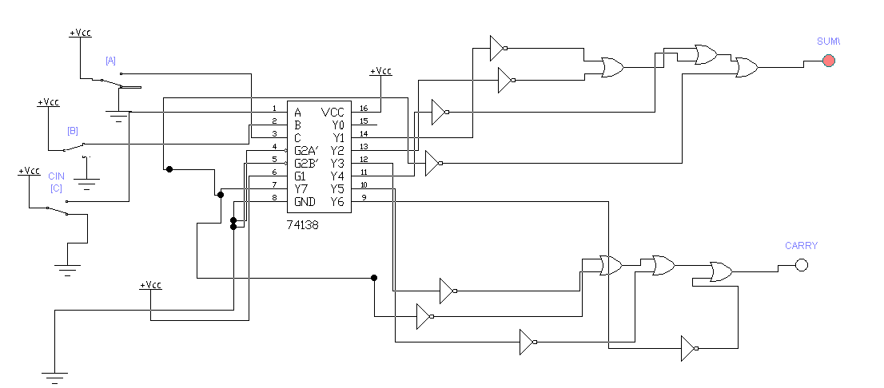

* **EXPLAINATION:**

**In 3*8 line Decoder, we have 3 input lines and 8 output lines. It converts the binary signal into decimal code from Y0 to y7 i-e 8 numbers. So according to the truth table, for sum, note the number of ones in the SUM-CLOUMN and sum(ORed) the related min-terms. similarly, for carry, note the number of ones in CARRY-COLUMN and sum(ORed) the related min-terms.**

**ii. two 4 *1 multiplexers. (Attach Simulated circuit diagram as well).**

* **TRUTH TABLE OF FULL ADDER:**

|  |  |  |  |  |
| --- | --- | --- | --- | --- |
| **A(MSB)** | **B** | **CIN** | **SUM** | **COUT** |
| **0** | **0** | **0** | **0** | **0** |
| **0** | **0** | **1** | **1** | **0** |
| **0** | **1** | **0** | **1** | **0** |
| **0** | **1** | **1** | **0** | **1** |
| **1** | **0** | **0** | **1** | **0** |
| **1** | **0** | **1** | **0** | **1** |
| **1** | **1** | **0** | **0** | **1** |
| **1** | **1** | **1** | **1** | **1** |

* **BOOLEAN EQUATION FOR SUM:**

**A’B’CIN + AB’C’IN + A’BC’IN + ABCIN**

**SUM= Σ (1,2,4,7)**

* **K-MAP FOR SUM:**

**AB CIN 0 1**

|  |  |  |
| --- | --- | --- |
| **I0**  **00** | **0** | **1** |
| **I1**  **01** | **1** | **0** |
| **I3**  **11** | **0** | **1** |
| **I2**  **10** | **1** | **0** |

* **EXPLAINATION:**

**From above K-MAP it is clear that in multiplexer I0 , I3 should be CIN and I1 , I2 should be C’IN(NOT).**

* **CIRCUIT FOR SUM USING 4*1 MUX:**

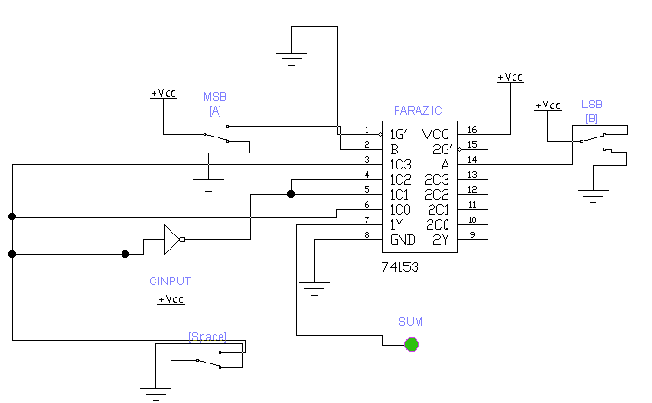

* **EQUATION FOR CARRY:**

**CARRY=Σ(3,5,6,7)**

* **K-MAP FOR CARRY:**

**AB CIN 0 1**

|  |  |  |
| --- | --- | --- |
| **I0**  **00** | **0** | **0** |
| **I1**  **01** | **0** | **1** |
| **I3**  **11** | **1** | **1** |
| **I2**  **10** | **0** | **1** |

* **EXPLAINATION:**

**From above K-MAP, it is clear that I0 will remain ‘0’ so it is connected to ground. Similarly, I3 will remain ‘1’ so It is connected to ‘vcc’ and I1 and I2 will remain which is CIN.**

* **CIRCUIT FOR CARRY USING 4*1 MUX:**

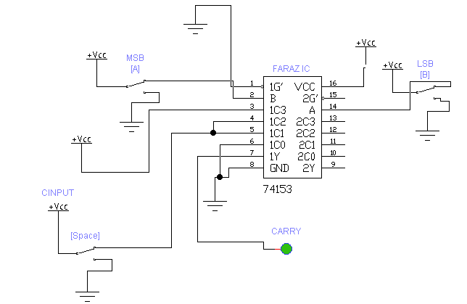

* **COMPLETE CIRCUIT OF FULL ADDER USING TWO 4*1 MUX:**

